# **Enterprise Computing and ERP Systems HT2021**

**Enterprise Computing and ERP Systems HT2021** **1**

**Week 1: Introduction goal modelling and conceptual modelling** **1**

Notes: Lesson 1 Goal Modelling 1

Key takeaways 2

Action items 3

Notes: Lesson 2 Conceptual Modelling 3

SBVR [Semantics Of Business Vocabulary And Business Rules] 5

# **Week 1: Introduction goal modelling and conceptual modelling**

[Add 6.9.2021 & 23:43]

[Add presenter here]

[Add topic here]

## **Notes: Lesson 1 Goal Modelling**

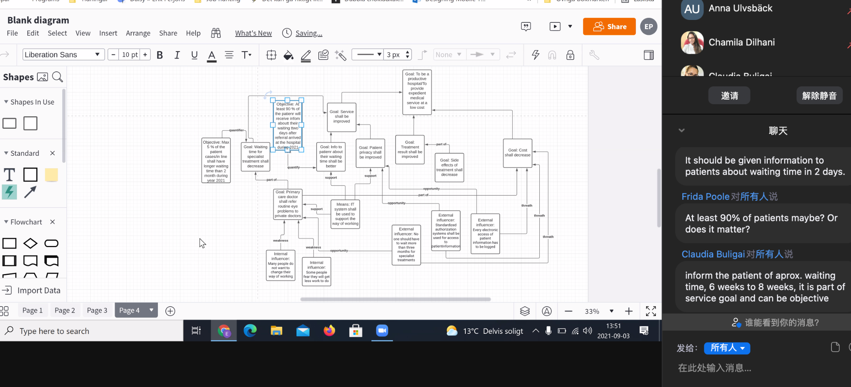

**Goal** = a desired state , something that the organisation only partially can influence

**Goals** can be decomposed from high level objectives to low-level requirements

Each goal refined with sub-goals that define how it can be satisfied

**Leaf-level goals** are considered to be requirements

**Means** = a course of action, and instrument or method, something that the organisation essentially can control

**Influencer** = a state of affairs that can impact an enterprise in its employment of means or achievement of goals

Two goals can be related to the same **objective.**

Two objectives can be related to the same goal.

**Objective quantifies goals**

**Assessment** = tells how an influencer impacts a means or a goal

One goal can be part of many other goals

One means can support several goals

**External influence:** opportunity, threat

**Internal influencer:** strength, weakness

An influencer can be both a threat and an opportunity

An influencer can be both a strength and a weakness

## **Key takeaways**

Construct a goal model for Google Assistant. The model should include at least:

* 6 goals
* 6 means
* One means for every leaf goal
* One objective for every leaf goal
* 6 influencers
* One influencer that is both a strength and a weakness (mark this one clearly in your diagram)
* One influencer that is both a threat and an opportunity (mark this one clearly in your diagram)

Your goal model is to include the following items:

* To make Google Assistant enjoyable to use (goal)
* Apple offers Siri, a competitor to Google Assistant (influencer)
* To make people use Google Assistant several times a day (goal)
* Amazon offers Echo, a competitor to Google Assistant (influencer)
* To ensure that Google Assistant can interact with many third party apps and services (goal)
* To collect a lot of data about users of Google Assistant (means)
* To make Google Assistant available on many devices (goals)
* To show ads that are relevant to the user (means)
* To give answers to queries that are relevant to the user (means)
* To have a good microphone in Google Home (influencer)
* To cooperate with vendors that offer apps and services (means)
* People nowadays regularly use many apps and services on their smartphones (influencer)

## **Action items**

* Add an action item here

## **Notes: Lesson 2 Conceptual Modelling**

* Domain model of business concepts (in UML Class diagram)
* Business Process model of business activities (in UML Activity diagram)
* Human interaction with software systems (in ULM Use Cases)
* Interaction between software objects (in UML Sequence diagram)
* System model of software objects (in UML Class diagram)

**Concept :** a concept is how we think about things or what we mean. A concept can be seen as thought unit or a mental view

**Term:** a term is a representation of a concept, a term can be seen as a sign for the concept, for example, in form of a word, a group of words (phrase), or a symbol

**The Relation btw Concept and Term**

* In order to express a concept, a term is needed
* If the relationship btw the term and the concept shall not be ambiguous, otherwise interpretation will be a problem
* Such a problem can be result of synonyms, polysemes, and homonyms

**Polyseme:**  it is a term that have a different but related meanings (“democracy” - different meaning in different economic systems, service-oriented development”)

**Homonym:** is two term with the same spelling or sound and have different

**Extension**

* **Extension** is the thing to which the concept (meaning) correspond, such as a physical thing
* Intention is the meaning of the term
* Definitions is a statement of the meaning of a term
  + Definitions are used to limit possible interpretations of a term
  + Definitions can be extensional or intentional

**Intentionsional definitions**

* Specifies the characteristics of the concept that a term represents. For example
* Intensional definition – specifies the characteristics of the concept that a term represent. For example, a ”barchelor” is a man that is unmarried, and a ”computer” is ....
* “A computer is a general-purpose device that can be programmed to carry out a set of arithmetic or logical operations automatically”.

**Extensional definitions**

* Extensional definition – lists every thing in the extension that falls under the definition. For example, if the term to define is ”computer” you need to list all computers, or the term is ”barchelor” you need to list all unmarried men in the world

**Guidelines for definitions**

* Use intensional definitions and not extensional definitions if possible
* Start the intensional definition by using the expression **”X is ...'' or ”X means ...”** where X is replaced by the term to be defined and the ”...” is the definition (barchelor is a man that is unmarried)
* Use the genus-differentia method when defining a term using an intensional definition

**Genus-differentia method**

* Exempel: A witness is a person that testify under oath at a trial
* The genus-differentia method means that a term is defined by using both:
* 1) the category (called genus) to which the item is suppose belongs to (such as person), and
* 2) the characteristics that separate the item from other items in the same category (called differentia)

**Concept -Term- Extension**

* The context- term -extension figure is similar to the semiotic/semantic triangle
* **语境-术语-扩展**
* **图类似于**
* **符号学/语义学三角**

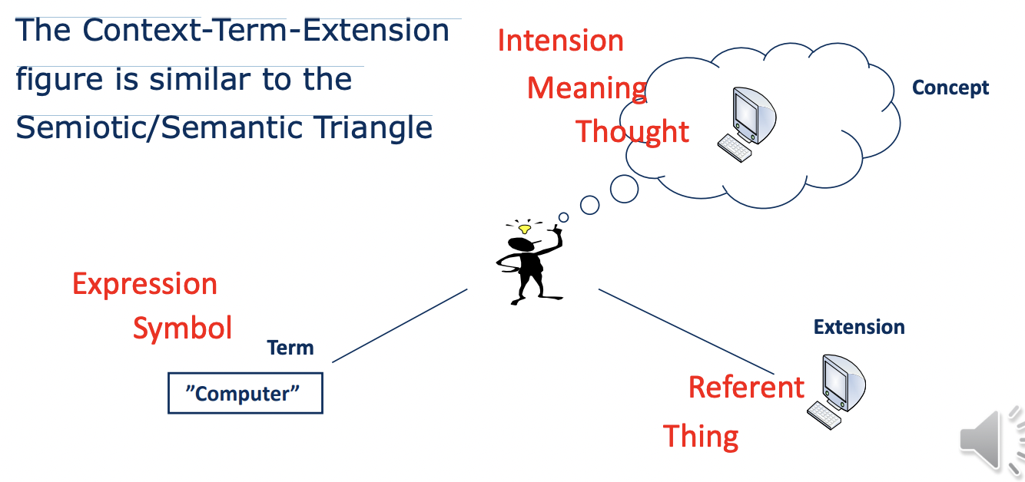

### SBVR [Semantics Of Business Vocabulary And Business Rules]

This specification defines the vocabulary and rules for documenting the semantics of business vocabularies and business rules for the exchange of business vocabularies and business rules among organizations and between software tools.

**SBVR**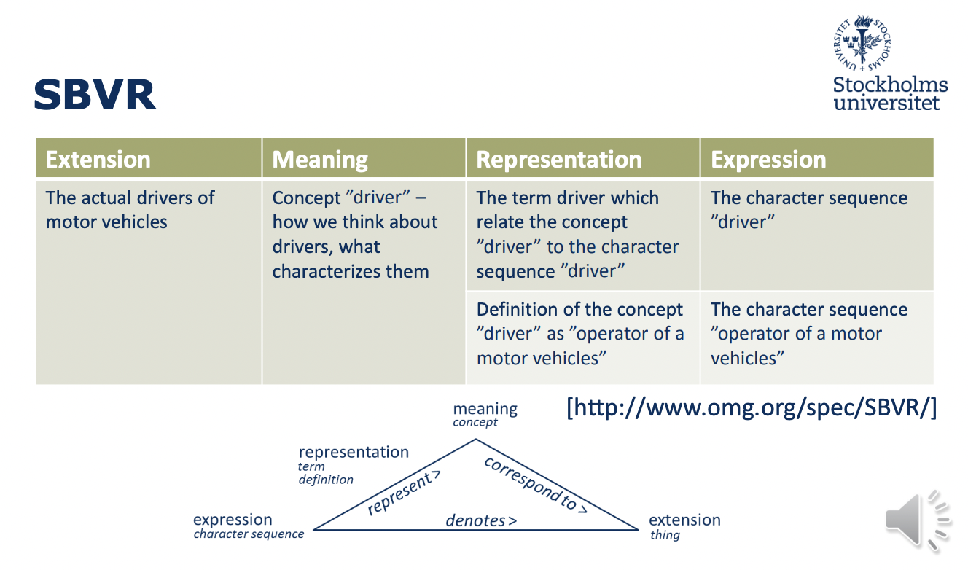

**Individual concept**

* + An individual (noun) concept – correspond to one specific thing, that is, one instance in the extension (the real world)

**General concept**

* + A general (noun) concept – correspond to two or more actual things that are grouped, that is, correspond to a group of instances in the extension (the real world)
  + This ”procedure” can be called classification

**Verb concept**

* + Things get involved in relationships with other things • A verb concept is the whole structure of a relationship and the related general concepts

**Individual fact**

* + Individual facts is the whole structure of a relationship and the related individual (and not general) concepts
  + Individual fact is something that may be found to occur in the extension (real world) or not (actual/not actual; true/false)

**Modelling instances**

| **Real world** |  | **Model world** |
| --- | --- | --- |
| **Elsa falk** |  | **Elsa falk** |
| **Gunnar Trana** |  | **Gunnar Trana** |

**Modelling a group of instances**

* Modelling a group of instances into a class is called classification
* Classification means (in practice) that properties that are common are highlighted and properties that differs between the instances are disregarded (for example, gender, hair colour, etc)

**Modelling attributes of class**

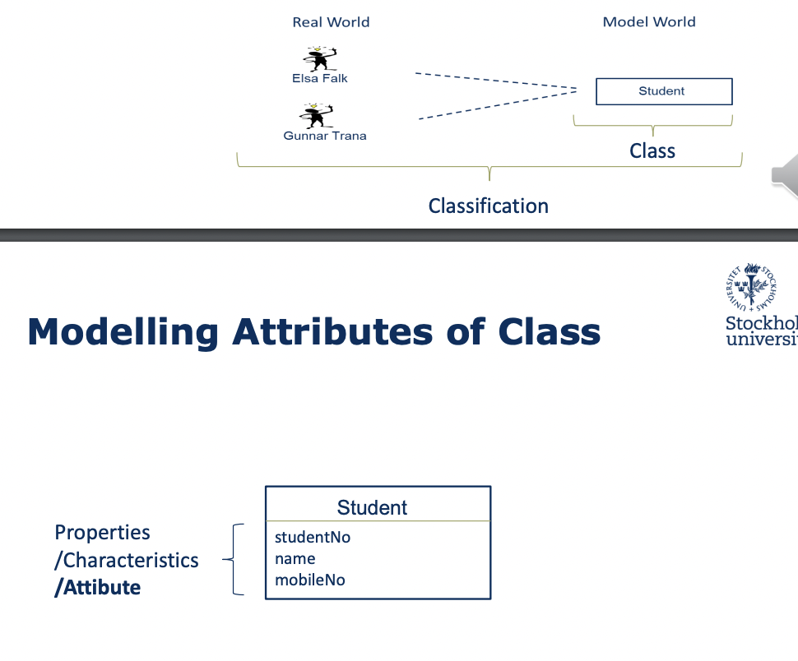

Creating objects from the class

* The class can be **used as a template** for creating model instances- often called **objects**. This “procedure” can be called **instantiation**

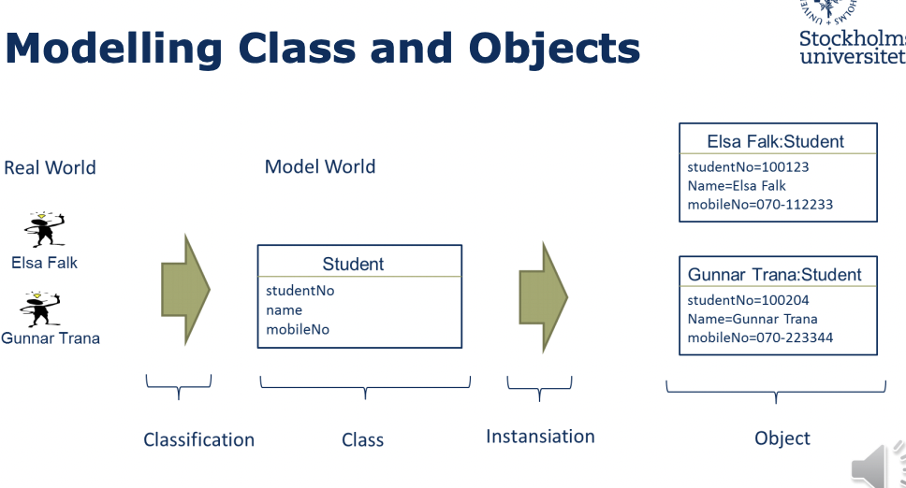

**Class and association structure**

* Relationships between classes are also modelled, creating a diagram/model (compare SBVR’s verb concepts)
* Relationships between classes are called associations in UML
* The diagram/model can be seen as a ”class and association structure”

### 3 Types of unary association

* Association … most general
* Whole-part relationship
  + Aggregation
  + Composition

Association:

Unary association

Class A -> Class B

Class A knows about Class B

Class B knows nothing about ClassA

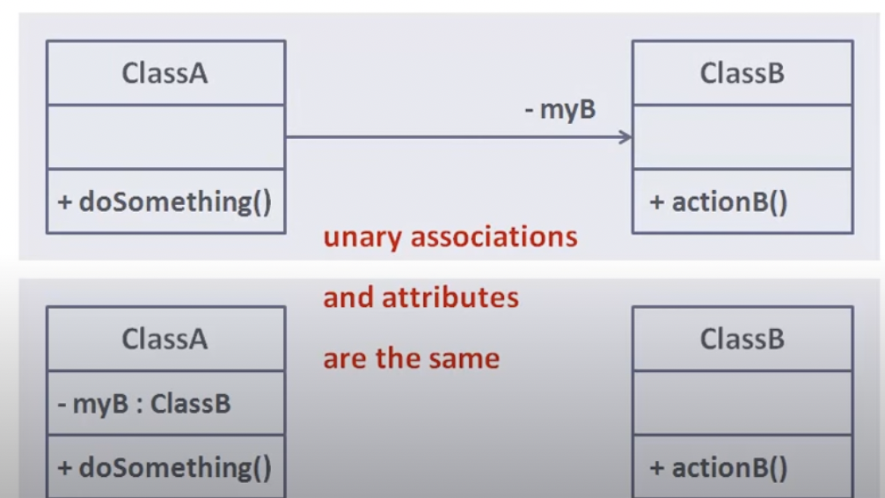

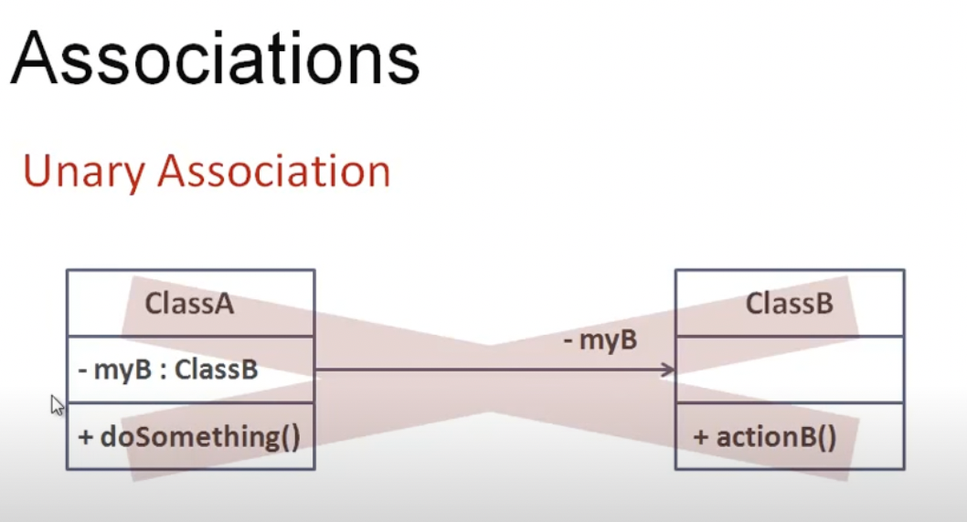

**Aggregation:**

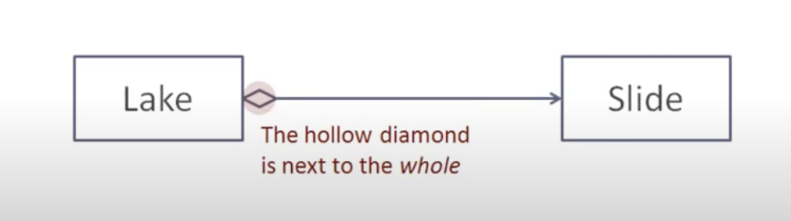

**Composition:**

Aggregation where the lifecycle of the part class depends on that of the whole class

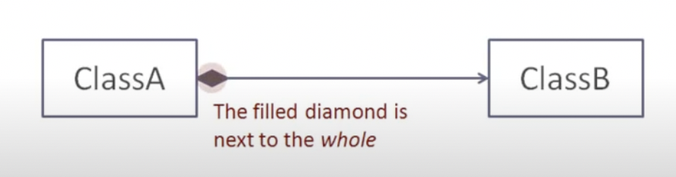

**Associations**

**Binary Association**

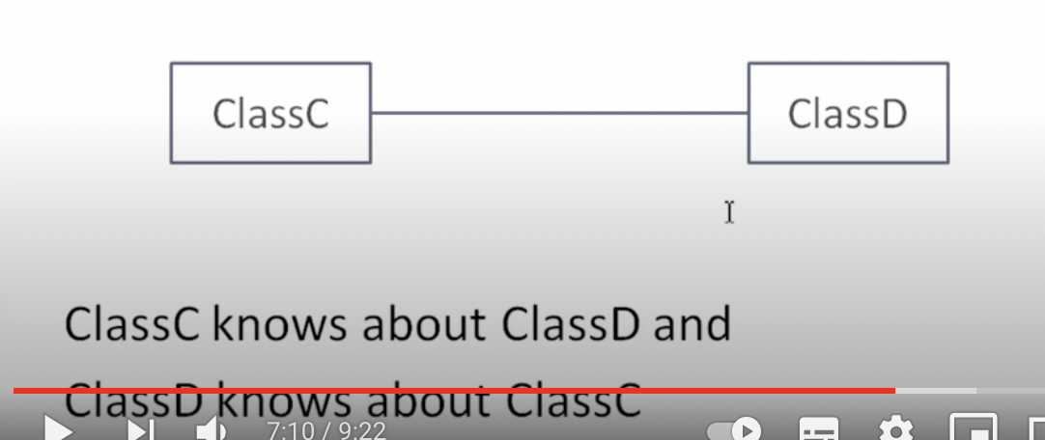

**Creating Object and Link Structures**

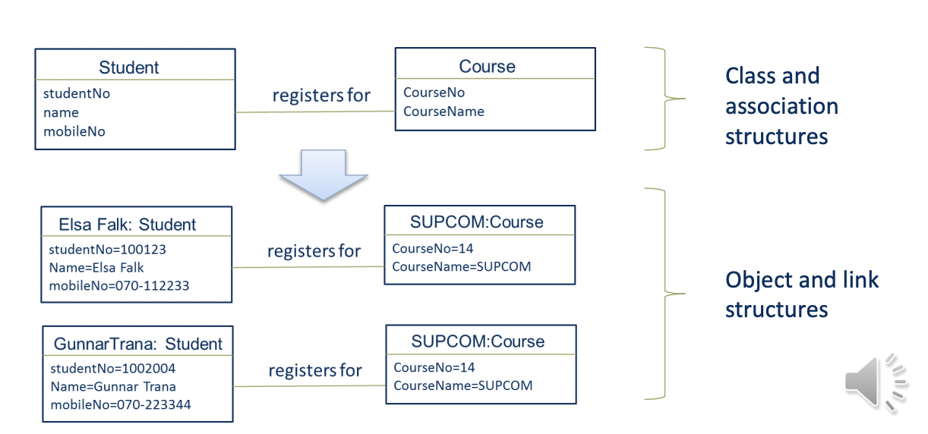

Object and link structures (compare SBVR’s individual facts) are usually not modelled, but could be:

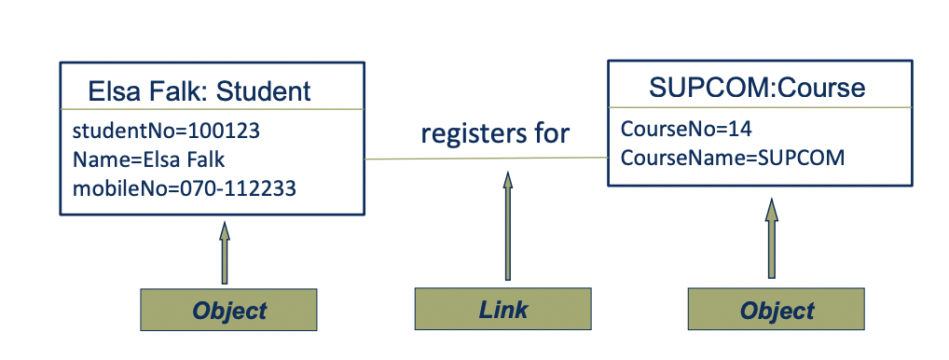

**Back to the Real World: Classification**

* **Classification** is grouping of instances
* It means (in practice) that attributes that differs btw the instances are disregard (for example, gender, hair colour) and properties that are in common are highlighted

**Generalization**

* Generalizeriing are grouping of classes, where classes totally include others
* The opposite to generalization is specialization
* Person is a generalization of woman and student
* Woman and student are specializations of person

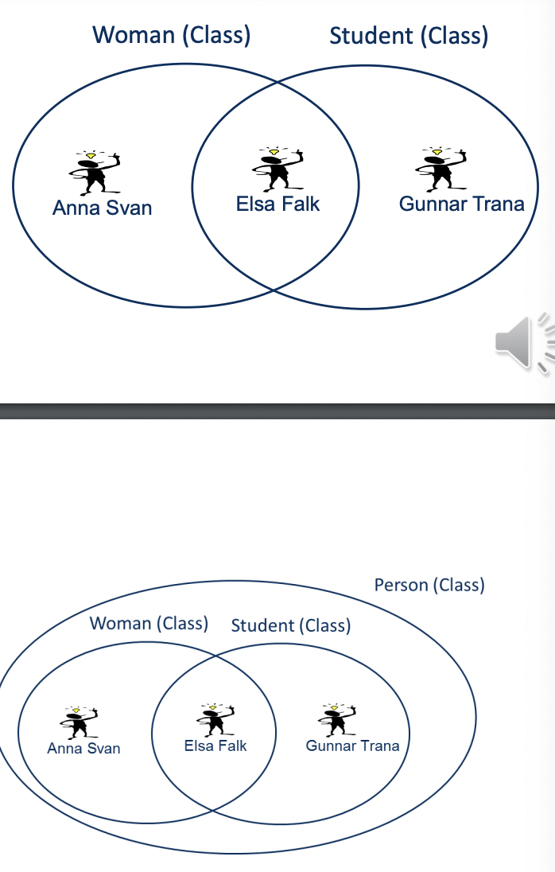

**Generalization Test**

* To test if a relationship between two classes is a generalization/specialization relationship :Ask if all instances in a specialized (sub) class are included in the generalized (super) class - if “yes” it is a generalization/specialization relationship
* Question: Is a woman a generalization of a student?
* Answer: No, there are instances of Student that are not instances of woman

**Multiplicity**

0..1 an optional instance (zero or one)

n exactly n instances

* zero or more instances

1..* one or more instances

n..m n to m instances

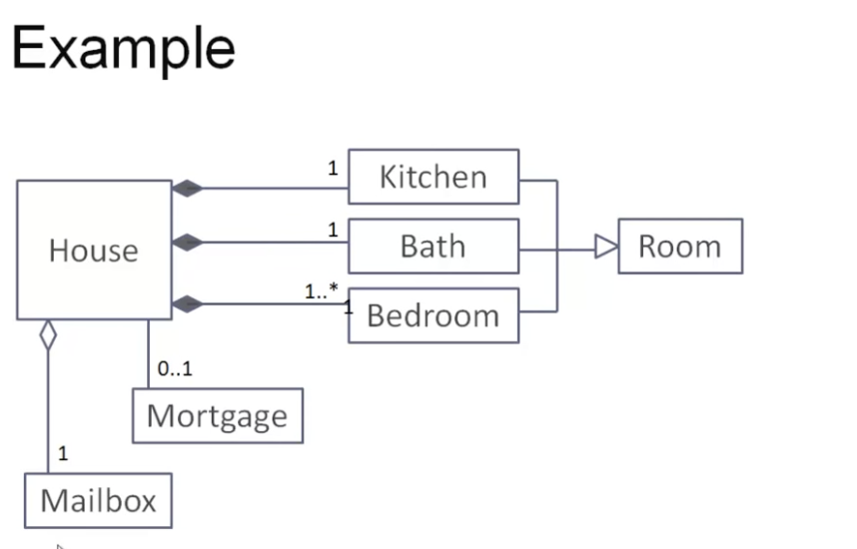

### Why Conceptual Modelling?

* **To specify terms and concepts that are - or should be -used in an organization. Thereby, support the development of a common vocabulary.**
* To specify terms and concepts for an information system so that the system use the same terms and concepts as the people in the organization, thereby supporting business and it alignment

**Why Conceptual Modelling?**

* To be used as a first step in developing a database system or a Java program (or a programme of some other programming language). The conceptual model can be also used by model driven development tools to generate part of the database schema or Java Code.
* To support integration between departments, organizations, information systems, by specifying the differences between terms and concepts used.

**Questions to answer:**

* What is a concept?
* What is a conceptual model?
* Why do we create conceptual models?
* What is classification and generalization?

### Guidelines

* Nouns and verbs

As a starting point: Nouns are modelled as classes (or attributes) and verbs as associations

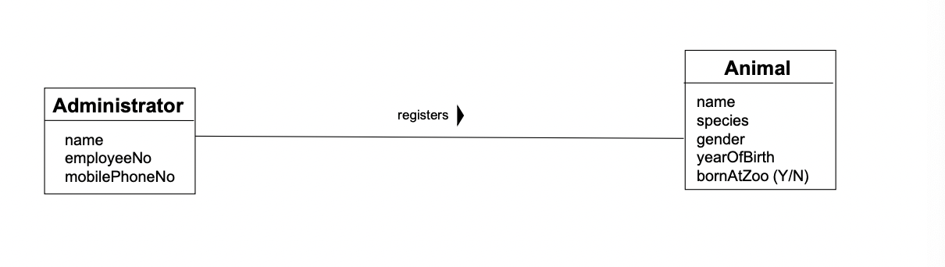

* Some associations shall be classes

Associations that need to have a date (or some other attribute), shall be transformed to classes.

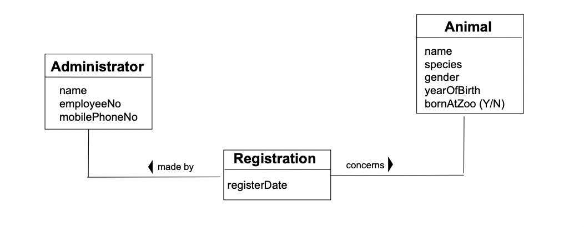

* Identify action/event classes -and note the multiplicity

It simplify modelling to early find the action/event classes - and note the common multiplicity from and towards these type of classes

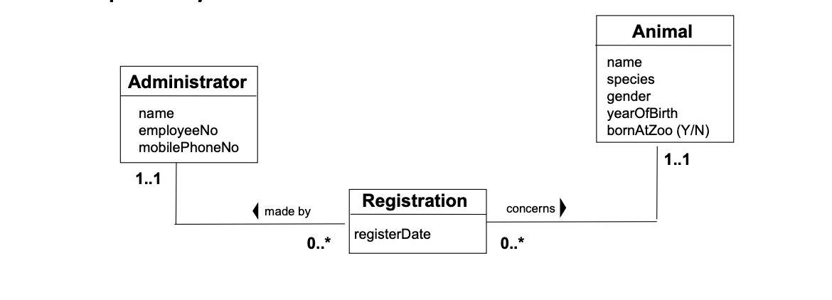

* Some attribute shall be classes

Attributes that can have several values should be transformed to classes. That is, the attribute should have the multiplicity 1..1, if not, create a new class for the attribute.

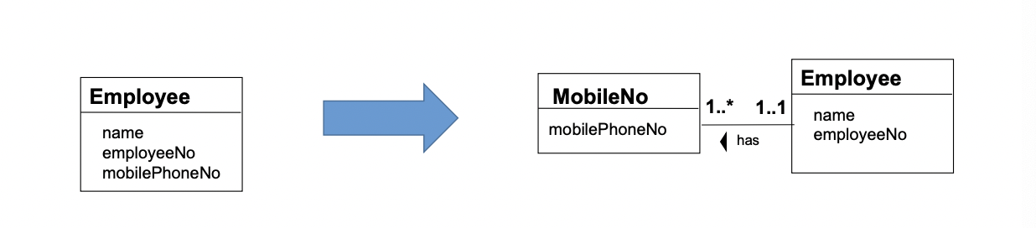

* Make use of generalizations

Make use of generalizations if possible. It makes the conceptual model easier to interpret.

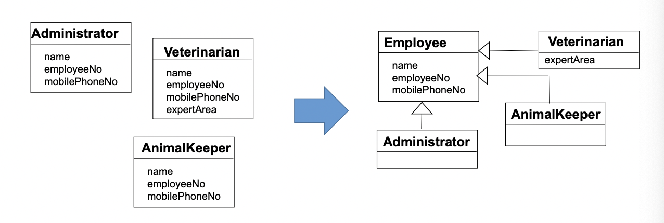

DO NOT MODEL OBJECTS

